
ORANGE COUNTY CLERK' S OFFICE RECORDING PAGE

TIDS PAGE IS PART OF THE INSTRUMENT -DO NOT REMOVE
TYPE IN BLACK INK:

NAME(S) OF PARTY{S) TO DOCUMENT

TO
SECTION BLOCK WT

RECORD AND RETURN TO:

(name and address)
THIS IS PAGE ONE OF THE RECORDING

ATTACH THIS SHEET TO THE FIRST PAGE OF EACH RECORDED INSTRUMENT ONLY
DO NOT WRITE BELOW TIDS LINE

INSTRUMENT TYPE: DEED MORTGAGE SATISFACTION ASSIGNMENT OTHER _

PROPERTY LOCATION
_2089 BLOOMING GROVE (TN)
_2001 WASHINGTONVILLE (VLG)
_2003 SO. BLOOMING GROVE (VLG)
_2289 CHESTER (TN)
_2201 CHESTER (VLG)
_2489 CORNWALL (TN)
_2401 CORNWALL (VLG)
_2600 CRAWFORD (TN)
_2800 DEERPARK (TN)
_3089 GOSHEN (TN)
_3001 GOSHEN (VLG)
_3003 FLORIDA (VLG) 3005 CHESTER (VLG)
3200 GREENVILLE (TN)
_3489 HAMPTONBURGH (TN)
_3401 MAYBROOK (VLG)
_3689 HIGHLANDS (TN)
_3601 HIGHLAND FALLS (VLG)
_3889 MINISINK (TN)
_3801 UNIONVILLE (VLG)
_4089 MONROE (TN)

_4289 MONTGOMERY (TN)
_4201 MAYBROOK (VLG)
_4203 MONTGOMERY (VLG)
_4205 WALDEN (VLG)
_4489 MOUNT HOPE (TN)
_4401 OTISVILLE (VLG)
_4600 NEWBURGH (TN)
_4800 NEW WINDSOR (TN)
_5089 TUXEDO (TN)
_ 5001 TUXEDO PARK (VLG)
_5200 WALLKILL (TN)
_5489 WARWICK (TN)
_5401 FLORIDA (VLG)
_5403 GREENWOOD LAKE (VLG)
_5405 WARWICK (VLG)
_5600 WAWAYANDA (TN)
_5889 WOODBURY (TN)
_5801 HARRIMAN (VLG)
_5809 WOODBURY (VLG)

CITIES

NO PAGES CROSS REF. _ CERT. COPY ADD'LX-REF•. _ MAP# PGS. _

PAYMENT TYPE: CHECK _
CASH _
CHARGE. _ NO FEE _
Taxable
CONSIDERATION $ _ TAX EXEMPT _
Taxable
MORTGAGE AMT. $ _

MORTGAGE TAX TYPE:
_ (A) COMMERCIAUFULL
_ (B) 1OR 2 FAMILY
_ (C) UNDER $10,000
_ (E) EXEMPT

_4001 MONROE (VLG)
_4003 HARRIMAN (VLG)
_4005 KIRYAS JOEL (VLG)
_0900

_llOO
_1300
MIDDLETOWN NEWBURGH PORT JERVIS
_ (F) 3 TO 6 UNITS
_ (I) NAT.PERSON/CR. UNION
_ (J) NAT.PER-CR.UN/1 OR 2
_ (K) CONDO

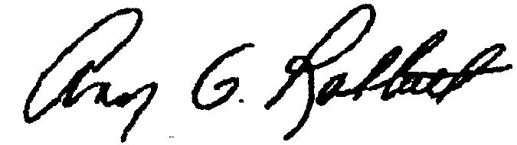
ANN G. RABBITT
ORANGE COUNTY CLERK
_9999 HOLD

Received From----------------

