AFFIDAVIT OF CREDIT ON MORTGAGE TAX

(Pursuant to §339-ee RPL)

State of New York } Title No.:
County of Westchester } ss. Date:

being duly sworn, deposes and says:

- I am the of , a New York with an office at .

- The Declaration of Condominium for the Condominiums (the “Condominium”) was recorded in the Office of the Clerk of the County of on as Control Number .

- Pursuant to Section 339ee(2) of the New York Real Property Law, a credit is requested against the mortgage tax on the first purchase money mortgage, securing the maximum sum of $ , placing a lien on Unit of the Condominium, which mortgage is offered herewith for recording, because of mortgage taxes totaling $ previously paid upon the recording of the following blanket or construction mortgage/mortgages totaling $ covering the property comprising the Condominium:

  - Mortgage made by to dated and recorded in the Office of the Clerk of the County of as Control Number , upon which mortgage tax in the amount of $ was duly paid;

  - Mortgage made by to dated and recorded in the Office of the Clerk of the County of as Control Number , upon which mortgage tax in the amount of $ was duly paid.

  - Mortgage made by to dated and recorded in the Office of the Clerk of the County of as Control Number , upon which mortgage tax in the amount of $ was duly paid.

- The total mortgage tax paid on the aforementioned mortgages was $ ; said mortgage tax is allocated as follows:

 | Mortgage  Amount | Basic  Tax  .5% | Additional Tax  .30% | *Special  Additional Tax  .25% | Westchester  County Tax  .25% | Total  1.3%
Mortgage A | $
Mortgage B | $
Mortgage C | $
Total
 |  |  |  | *No Credit Allowed

- The proceeds of the foregoing mortgages were applied exclusively to the construction of the Unit and/or have been and/or are being used exclusively for capital expenditures and expenses for the development or operation of the condominium or have been applied to the purchase of land or buildings for the condominium, which purchase was no more than two years prior to the recording of the declaration of condominium.

- The first unit at the condominium was sold within two (2) years after the foregoing mortgages were recorded.

- This affidavit is made in connection with the first sale of Unit No. at the Condominium, together with an appurtenant % interest in the Common Elements, in connection therewith purchaser is executing a purchase money mortgage in the amount of $ , and the aforementioned underlying mortgages are being released as to said Unit and its appurtenant interest in the common elements.

- That pursuant to Section 339-ee of the New York Real Property Law, the Mortgage Tax due and payable on the aforementioned purchase money mortgage is as follows:

 | A |  | B | C
 | Unit Mortgage Tax |  | Credit Allowed for Units  Share of Common Element of Condominium | Tax Due and Payable Herewith
1. Basic Tax: | (Purchaser mtg. amount x .50%) =  $___________________________ |  | (Total Basic Tax on blanket mortgage x common elements) =  $______________________ | Basic Tax Due  A – B = C  $___________________
2. Additional Tax: | (Purchaser mtg. amt x .30%) – 30.00=  $___________________________ |  | (Total Additional Tax on Blanket Mortgage x common elements) =  $______________________ | Additional Tax Due  A – B = C  $___________________
3. County Tax: | (Purchaser mtg. amount x .25%) = |  | (Total County Tax on Blanket Mortgage x common elements)= | County Tax Due  A – B = C
 | $___________________________ |  | $______________________ | $___________________
4. Total Tax Due  From Mortgagor: |  |  | Tax Due from Mortgagor (C1 +C2+C3): | 4. $_______________
5. Special Additional  Tax: | (Purchaser mtg. amount x .25%) =  $___________________________ |  | No Credit Allowed  (Paid by Lender) | 5. Special Additional Tax  $_______________
6. Total Tax Due  From Lender: |  |  | Tax Due from Lender (C5): | 6. $_______________
7. Total Tax Due: |  |  | Total Tax Due (C4 + C6): | 7. $*______________
 |  | Total Unit Mortgage Tax PRE-Credit:  (Purchaser mtg. amount x 1.3%) - (30.00)  A5 |  | 8. $ ______________
 |  | Less Total Tax Due  C7 |  | 9. (*______________)
 |  | Total Mortgage Tax Credit  (difference between Tax PRE-Credit and Total Tax Due)  (C-8 – C-7) |  | 10 **______________

- Wherefore, your deponent respectfully requests that the aforesaid purchase money mortgage be declared exempt from taxation to the extent of $** C10 pursuant to Section 339-ee of the New York Real Property Law and that said mortgage be accepted for recording upon the payment of the sum of $* C7 which is tendered herewith.

___________________________________

On the day of , 2008 before me, the undersigned, personally appeared , personally known to me or proved to me on the basis of satisfactory evidence to be the individual(s) whose name(s) is(are) subscribed to within instrument and acknowledged to me that he/she/they executed the same in his/her/their capacity(ies), and that by his/her/their signature(s) on the instrument, the individual(s), or the person upon behalf of which the individual(s) acted executed the instrument.

__________________________
Notary Public

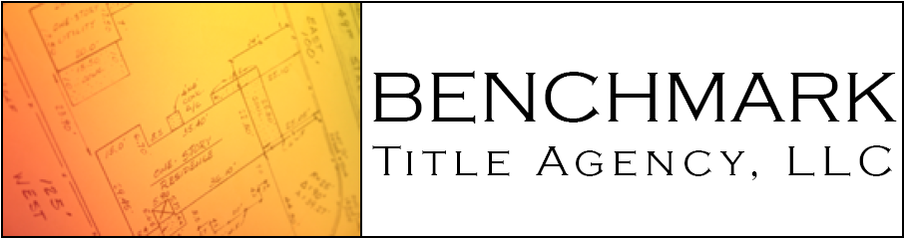

222 Bloomingdale Road, Suite 102
White Plains, NY 10605
Phone 914-250-2400 Fax 914-422-1550

